

EXAMINATION BOOKLET FOR STUDENTS 2025/2026

Name: _______________________________

Examinations are very important times in your life at Furness Academy. The examinations you will be taking will influence what you will do in the future, so it is very important that they run as smoothly as possible.

There are a number of rules and regulations for examinations that you must be aware of. These are set by the Awarding Bodies. If you do not adhere to these rules then you may be disqualified from your examinations.

Read this booklet carefully and if there is anything you do not understand ask the Examinations Officer or a teacher for help.

DO NOT LOSE THIS BOOKLET

This booklet has been put together to provide you and your parents/carers with the information you will need for examinations.

Contents

- Examination Check List
- Furness Academy Examination Entry Policy 2025/26
- Examinations Rules and Furness Academy Procedures—guidance to candidates
- Essential Dates
- Before Examinations
- Conduct in Examination Hall
- End of Examinations
- Internal Assessment Policy/Appeals
- Emergency Evacuation Procedures
- JCQ Information

Useful Information
Centre Number – 42305
Academy Telephone Number – 01229 484270

EXAMINATION CHECK LIST

     |  | TRAVEL  Allow plenty of time to get to school for an exam. It is much better to leave yourself a safety margin on timings in case of problems with the journey.  BAGS  Bags and coats should be left in the designated area.  MOBILE PHONES  Phones – Students must not have mobile phones in their possession. They should be switched off and stored in your bag.  This is very important – If a phone is found on your person your whole Examination may be cancelled.  Unauthorised Materials & Devices  You should not have notes, Smart Watches, or any type of electronic device in your possession. The same rules apply for these items as they do for phones.
    Sshh! | WATCHES  Students must not bring any type of watch into the exam room  STATIONERY  You should bring pens (BLACK INK), pencils, rubbers and any other equipment needed for your examinations, including a calculator. Only clear pencil cases are allowed on your desk, any others should be left in your bag, or on the floor of the examination hall if accidentally brought in. Do not use gel pens – many of the examination papers are now scanned and sent electronically for marking – gel pens do not scan well  SCIENTIFIC CALCULATORS  In an examination where you have the use of a calculator, you should not have a calculator cover on your desk – please place on the floor.  TALKING  There is absolutely no talking or communication between students once you enter the examination hall. If you have any questions, you should raise your hand once seated and an invigilator will come to you.  FOOD  No food allowed in the examination hall. If you have a special requirement please see the Examinations Officer, before the examinations  WATER  Water bottles are allowed in the examination hall. These should be clear bottles with a spill-proof cap. There should be no label, print or pattern on the bottle.

March 2026

Dear Parents/Carers

EXAMINATION ENTRY - SUMMER 2026

Entry Costs
The entry cost for each GCSE, BTEC and other technical examination is paid for by Furness Academy. If a student fails to attend an examination through their own lack of personal organisation the school may require parents to refund the cost of the examination entry fees.

Illness/Accidents
Failure to sit an examination for which an entry has been made will result in the examination board automatically awarding 0 marks to the candidate for that paper. The only conditions where an examination board and Furness Academy will make an exception to this are serious illness or where an accident has prevented the student attending the examination. In these circumstances the Examinations Officer should be informed as soon as possible and supporting evidence, such as a doctor’s note or police report, provided within three days of the examination date. An application for special consideration will then be submitted to the examination board.

Statement of Entry & Timetable
Students will be provided with two documents – a statement of entry form and a timetable. Please check all details carefully, especially the legal name on the documents and report any mistakes or problems to Mr Powell (Examinations Manager). If there is anything you are not clear on, please ask.

- Statement of Entry
Please check the entries are correct, both the subject and level (Foundation or Higher).

- Timetable
Students will receive an initial individual timetable showing the date and time of their examinations. In April students will then receive a fully personalised timetable showing the venues where they will be sitting examinations, seat references and exact timings for examinations. The dates and times for examinations are fixed nationally and cannot be changed.

This is an important time for your child and detailed preparation is essential for the smooth running of the examination season. We want all our students to achieve their personal best and ask that you support your child in the run up to these important examinations.

If you have any concerns regarding these examinations or would like further information, please do not hesitate to contact Mr Powell (Examinations Manager) at Furness Academy.

Yours sincerely


Mrs H Robinson
Headteacher

Examination Rules and Furness Academy Procedures

Examination Process

As part of the checking process for entry to examinations you will be issued with the following:

1. Statement of entry
2. Provisional timetable (clashes not resolved)
3. Final timetable (clashes resolved)

Statement of Entry and Timetables

Please check the entries are correct. Both the subject and level (Foundation or Higher).
If there are ANY mistakes (e.g. name, date of birth, examination entry) you MUST tell the Examinations Officer immediately. Mistakes that are not identified at this stage could mean your certificate is incorrectly printed later.
Check each examination date carefully and check to see if the examination is in the morning or the afternoon.

Take special note of any re-arrangements due to timetable clashes. These will be detailed on your final timetable issued before examinations start.

YOU AND YOU ALONE ARE RESPONSIBLE FOR CHECKING YOUR EXAMINATION TIMETABLE

TIP – Pin your timetable to your fridge, add reminders on your tablet and ask family members to be aware of the dates. They can then remind you if you forget.
Times
Unless otherwise stated on your timetable, all examinations start at 9.00am for morning papers and 1.30pm for afternoon papers. Remember to check your timetable carefully. Prior to most exams students will gather in a designated area and be sent to the exam venue(s) by a member of Senior Leadership.

PREPARE, PREPARE, PREPARE!

Plan your examination preparation carefully and thoroughly, but most of all
GOOD LUCK!
Lateness

If for any reason you are going to be late and will miss the start of the examination, you MUST telephone the Academy (01229 484270)

If you are more than an hour late the examination board could award you zero marks for the papers.

If you are late the Academy will decide whether:-

• To allow you to take the examination.

The examination board will decide whether:-

• To accept the work.

Absence from Examinations

You MUST attend all examinations on your personal timetable. Misreading the timetable is not a satisfactory reason for absence.

If you miss an examination due to illness:-

- You must telephone the Academy as soon as possible on:

01229 484270

2. If applicable, you must provide a medical certificate to the Examinations Officer within 3 days of the examination you missed.

If you miss an examination without a valid reason, Furness Academy may ask your parent/carers to reimburse the entry cost.

Cheating

Make sure you know the rules!

Do not become involved in any unfair or dishonest practice.

If you are caught cheating in an examination, you WILL be reported to the Awarding Body. Cheating means doing anything that is against the rules stated on the Warning to Candidates, which is included in this booklet, and includes:-

• Being in possession of a watch, mobile phone or any other internet enabled device including but not exclusive to Smart Watches (e.g. Apple iWatch), MP3 devices (e.g. Apple iPod), or any other prohibited electronic equipment with storage or communication functionality. Including calculators with stored memory.

• Using unauthorised aids (e.g. notes)

• Communicating with other candidates in any way.

• Copying from other candidates.

Penalties for cheating can include disqualification from taking any examination for up to 5 years.

Equipment

You must provide all your own equipment.

You should bring your equipment in a clear plastic bag or transparent case. Any other type of pencil case is NOT allowed in the examination room.

The following equipment should be brought to EVERY examination:

• 2 pens — black only
• 2 HB pencils
• Ruler (marked with millimetres)
• Pencil sharpener
• Rubber

For some examinations you will also need the following:

• Compasses
• Protractor
• Calculator

You are NOT allowed to use any type of correcting fluids or pens.

Mobile Phone / Electronic Device Malpractice

The following devices are NOT allowed in the examination hall:

Mobile Phones, Watches, Electronic Organisers, Music Players, Electronic communication or web enabled / storage devices.

If you accidentally bring any of these into an exam, you MUST switch them off and hand to an invigilator immediately.

If your mobile phone is in your possession even though it is switched off, you risk receiving ZERO marks for your paper.

If you use your mobile phone, you will be DISQUALIFIED from the subject by the examination board.

The same rules also apply to any other electronic device with storage or communication functionality.

Watches

Students cannot take ANY type of watch into the exam hall. If a student is still wearing a watch, they must give it to an invigilator immediately.

Calculators

Calculators may be used in most examinations. You will be advised if it is a non-calculator paper or you can check with your subject teacher prior to the examination.

You must bring your own calculator. The Academy cannot guarantee there will be spare calculators on the day.

You are not allowed to use a mobile phone/tablet as a calculator.

The Awarding Bodies do not make allowances for calculator failure or operational mistakes – You are responsible for making sure your calculator works properly.

Your calculator must be of a size suitable for use on a desk and be battery or solar powered.

Calculators must not:-

• Have alphabetic keys
• Be programmable
• Have noisy keys which could disturb others.
• Have a permanent memory

Drinks

You are only allowed to take a drink of water in a clear plastic bottle with the label removed into the examination room.

You will NOT be allowed to leave the room to refill a bottle of water, and invigilators cannot do this for you, so please make sure you have enough for the whole examination.

Did you know?-By the time you feel thirsty, 20% of your brain has already shut down
Essential Dates for Summer 2026
March
Students receive Statement of Entry—check name, date of birth, entries. Any problems contact Mr Powell (Exams Manager) immediately.
April
Students receive final personal timetables. This will include details of individual examination dates, times and locations. Students will be given clear instructions about examination procedures and expectations.
May/June
Examinations take place. Friday 1st May to Wednesday 17th June
JCQ Exam Contingency Dates – Wednesday 24th June. In the event of any examinations needing to be rescheduled nationally these are the dates set by JCQ to be used. Students need to be available on these dates otherwise they risk being awarded zero marks for the paper.
There will be no period defined as study leave.

August
RESULTS DAY! - Thursday 23rd August
Autumn Term
Awards Evening – GCSE certificates will be issued at this event during the autumn term.
GCSE Certificates
GCSE certificates are stored for 12 months after the Awards Evening. After 12 months the certificates are destroyed, if you need replacements these can be obtained through the awarding body. However, there is normally a charge of £50+ per certificate.

Before the Examination

You should be wearing correct uniform – you may not be allowed into the examination room if you are not correctly dressed.
Check the seating plans outside the examination venues.
All bags and coats are to be left in the specified areas. Coats must not be worn during the examination.
Make sure you have been to the toilet. You may not be allowed to go once you have entered the examination hall.
Conduct in the Examination Hall

You must be silent at all times when you are in the examination room. This includes from when you enter to when you leave.

At the start of each examination you will be asked to hand in any unauthorised materials – this will be your last chance to hand in mobile phones, watches etc.

Tell the invigilator at once:

• If you think you have not been given the right question paper (higher / foundation) or all the materials listed on the front of the paper

• If the question paper is incomplete or badly printed

Read and carefully follow the instructions printed on the question paper and/or on the answer booklet.

You will be told the start time and duration of the examination. The start and end times will be written on the board at the front of the examination hall and displayed around the room.

Listen to the invigilator and do what you are asked.

Fill in the details required on the front of the question paper and/or the answer booklet before you start the examination.

If you need assistance, put your hand up clearly and wait for an invigilator to attend to you.

Do your rough work only on the proper examination stationery. Remember to cross through anything you do not want marked and hand it in with your answers.

If you have finished the examination early, you will NOT be allowed to leave the room. Use this time to check your work.

If the Examinations Officer is unhappy with your behaviour, you will be escorted to a waiting area outside of the examination hall. You will remain there until collected by a member of staff. You must remain silent throughout this process. A report will also be submitted to the Awarding Body detailing any such incidents and you will have opportunity to give a written statement for submission to the Awarding Body.

End of the Examination

The invigilators will collect your examination paper before you leave the room.

Absolute silence MUST be maintained during this time.

Question papers, answer booklets and additional paper must NOT be taken from the examination room.

You will be dismissed from the examination row by row.

You must remain silent until you are away from the examination venue. Other examinations may still be taking place.

Special Consideration

Special consideration can only be applied if something has seriously affected your performance on the day of an examination. Examples of acceptable reasons for applications are bereavement, injury or illness (you will need a doctor’s note). If after the examination you think you have a good reason for applying for Special Consideration you will need to contact the Examinations Officer within 3 days of the examination.

Timetable Clashes

If you have any clashes, arrangements will be made for you to take the subjects one after the other.

If this happens to you, you will be supervised by an invigilator at all times when you are not in the examination.

If you notice a clash on your final timetable which is not resolved, you must tell the Examinations Officer immediately.

Clash Supervision

You will be informed in advance of any clash arrangements.

During clash supervision you will not be allowed to communicate with anyone else and will not be allowed to use your mobile phone or any other communication device. If you need to be supervised over lunch time arrangements will be made to allow you to access the catering facilities.
Internal Assessment Policy /Appeals

Policy on Internal Assessments for Qualifications with English Awarding Bodies

In accordance with the Code of Practice for the conduct of external qualifications produced by the QCA, Furness Academy is committed to ensuring that:

- Internal Assessments are conducted by staff who have the appropriate knowledge, understanding and skills.
- Assessment evidence provided by candidates is produced and authenticated according to the requirements of the relevant specifications for each subject.
- The consistency of internal assessment is assured through internal standardisation as set out by the Awarding Bodies.
- Staff responsible for internal standardisation and/or assessment attend any compulsory training sessions.

Written Appeals

Each Awarding Body publishes procedures for appeals against decisions, and the Examinations Officer will be able to advise students and parent/carers of these procedures.

Appeals may be made to the school regarding the procedures used in internal assessment.

A pupil or parent wishing to appeal against the procedures used in internal assessments should contact the Examinations Officer as soon as possible to discuss the appeal. A written appeal must be received by the Examinations Officer at least two weeks before the date of the last external examination for that subject.

On receipt of a written appeal, an enquiry into the internal assessment will be conducted by the Examinations Officer and a member of Senior Leadership. This enquiry will consider whether the procedures used in the internal assessment conformed to the published requirements of the Awarding Body.

The appellant will be informed in writing of the outcome of the appeal, including details of any relevant communication with the Awarding Body and of any steps taken to further protect the interests of the candidates.

Students should note the following:

If at any stage during your examination courses you have concerns about the procedures used in assessing your internally marked work for public examinations (e.g. controlled assessments /coursework/portfolios/projects) you should see the Examinations Officer as soon as possible.
Emergency Evacuation Procedure

In the event of an emergency, all students must adhere to the following instructions:

Signal – Alarm siren or Bell for prolonged period.

On hearing the alarm, pupils will stop writing, close their examination booklets and await instructions from the invigilators

If necessary, students will vacate the examination hall one row at a time via the emergency exits under the direction of the Exams Officer and examination invigilators.

Examination papers will be closed and left on desks along with any equipment. All belongings will be left in the building.

Students will exit in an orderly manner and are expected to remain in silence to avoid any breach of the security of the examination.

Finishing the Examination

Depending on the emergency, pupils will be admitted back into the hall as soon as it is deemed safe.

Students will re-enter a row at a time, taking their original seat—Examination material is to remain closed until instructed to restart.

Students will be given the full-time allocation for the examination and allowed to finish.

The incident will be reported to the Awarding Body requesting consideration for the disruption be taken into account when marking.

During an evacuation if a student is suspected of malpractice (communicating or trying to gain an unfair advantage) a report will be given to the Awarding Body to consider.

JCQ Information to Candidates

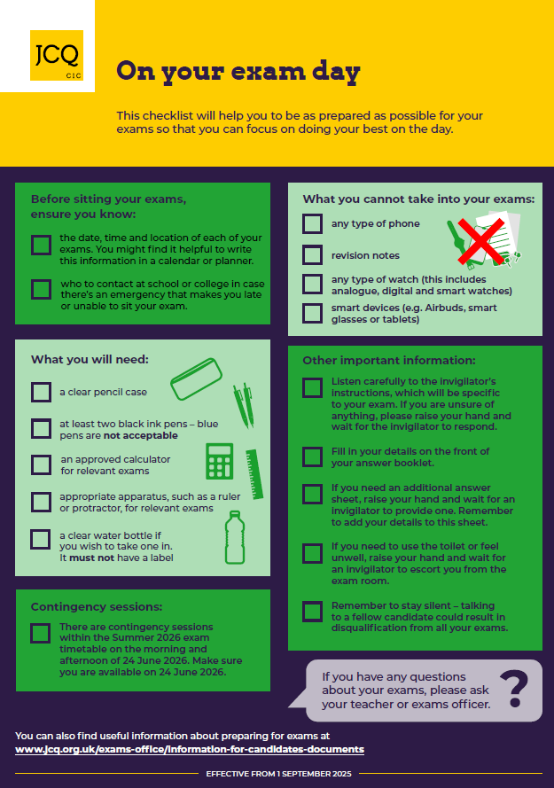

FINALLY,
THANK YOU FOR READING THIS BOOKLET.

GOOD LUCK WITH YOUR EXAMINATIONS!

