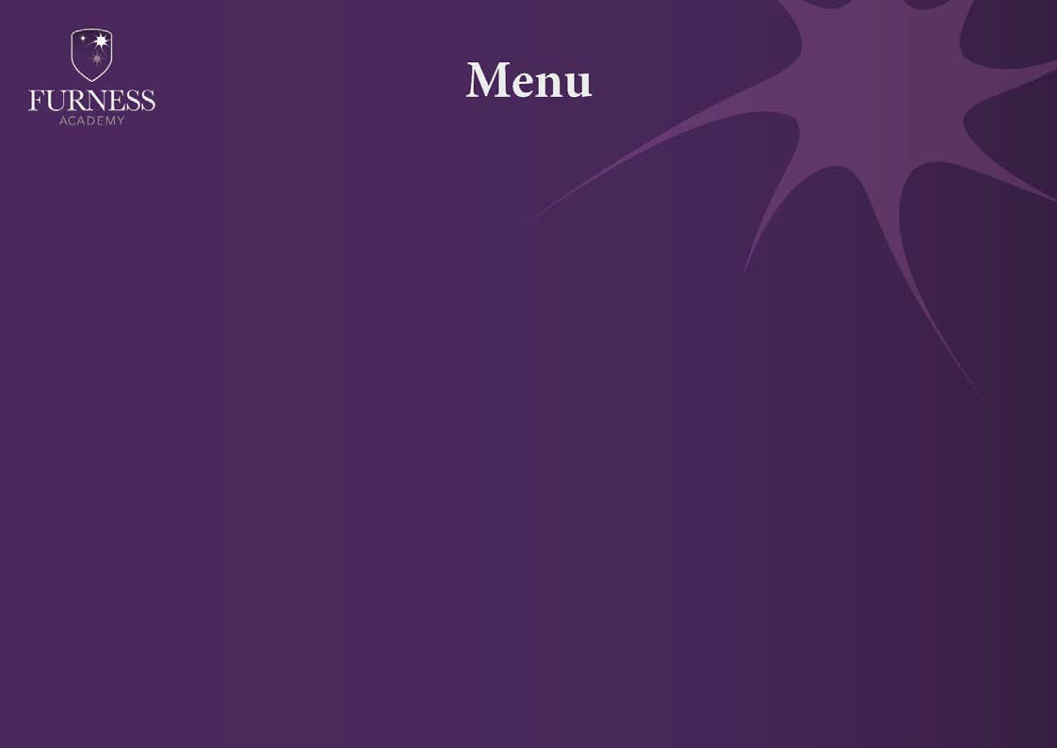
Week 1

Soup | Carrot and Coriander | Leek and Potato | Mushroom | Tomato and Basil | Vegetable
Meal Deal  £2.65  (Includes side dish and dessert) | Chicken tikka and rice | Pasta Bolognaise | Chicken breast burger in a bun | Roast Gammon dinner | Baked fish and chips  or  Salmon fish cake
Main Courses | - Cheese and tomato pizza  - Loaded satay chicken potatoes | - Cheese on toast  - Chicken kebab with salad, wrap and sweet chilli sauce | - Cheese and tomato pizza  - Chicken curry and rice | - Hot cheese baguette  - Seasoned chicken flatbread  - Beans on Toast | - Sausage Roll  - Chips and toppings
“One stop spud shop” | Chinese chicken Bolognaise Korma Chicken Fajita  Various cold fillings and beans available daily also includes salad, garlic butter, crispy onions and sauces
Side Dishes | - Naan bread  - Beans  - Seasonal veg  - Salad  - Coleslaw | - Garlic Bread  - Beans  - Seasonal veg  - Salad  - Coleslaw  • Peas | - Naan Bread  - Beans  - Seasonal veg  - Salad  - Coleslaw | - Beans  - Seasonal veg  - Salad  - Yorkshire pudding  - Coleslaw | - Beans  - Salad  - Coleslaw  - Curry sauce and Gravy
Desserts | - Selection of fruit  - Mousse  - Tray bakes  - Cheesecakes | - Selection of fruit  - Mousse  - Tray bakes  - Cheesecake | - Selection of fruit  - Mousse  - Tray bakes  - Cheesecakes | - Selection of fruit  - Mousse  - Tray bakes  - Cheesecakes | - Selection of fruit  - Mousse  - Tray bakes  - Cheesecakes
A variety of sandwiches and baguettes will be available daily
Assorted Salad boxes and cold pasta pots available on request (24hrs notice required)
Allergens available on request

