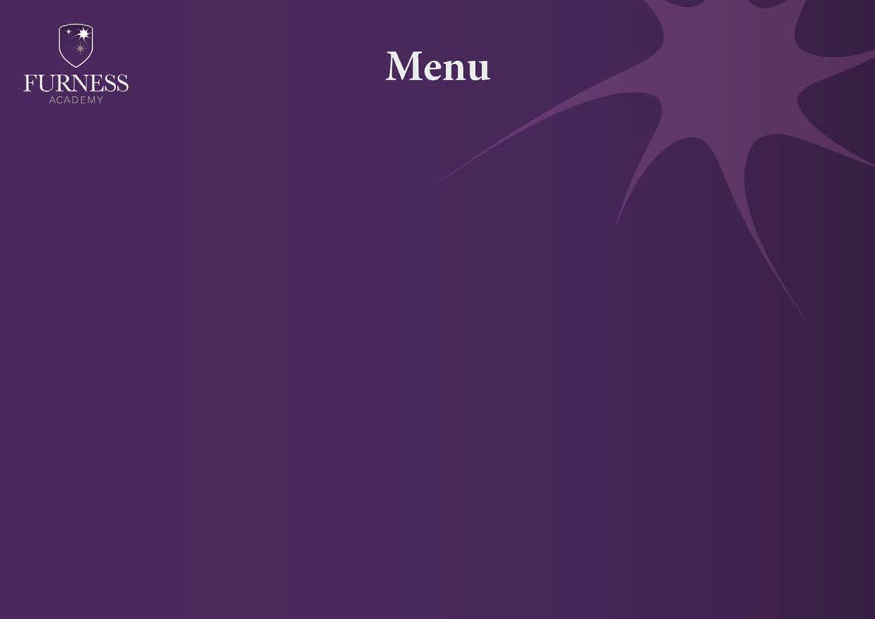
- Week 2

Soup | Roasted Vegetable | Pea and Ham | Minestrone | Chicken & Sweetcorn | Beef and Tomato
Meal Deal  £2.65  (Includes side dish and dessert) | Macaroni cheese | Chicken and chickpea curry | Chicken casserole | Roast chicken lunch | Baked fish and chips
Main Courses | - Satay chicken and potatoes  - Cheese and tomato pizza | - BBQ chicken kebab  - Hot cheese baguette  - Beans on toast | - Salt and pepper chicken burger  - Cheese and tomato pizza | - Hot chicken baguette  - Fajita chicken flatbread  - Beans on Toast | - Sausage Roll  - Chips and toppings
“One stop spud shop” | Cajun Chicken Garlic chilli Chicken Chilli Sweet chilli meatballs  Various cold fillings and beans available daily also includes salad, garlic butter, crispy onions and sauces
Side Dishes | - Garlic bread  - Beans  - Seasonal veg  - Salad  - Coleslaw | - Rice  - Beans  - Naan bread  - Seasonal veg  - Coleslaw  - Salad  • Peas | - Beans  - Seasonal veg  - Coleslaw  - Salad | - Beans  - Mashed potato  - Seasonal veg  - Coleslaw  - Salad | - Beans  - Salad  - Mushy peas  - Curry sauce and Gravy
Desserts | - Selection of fruit  - Mousse  - Tray bakes  - Cheesecakes | - Selection of fruit  - Mousse  - Tray bakes  - Cheesecakes | - Selection of fruit  - Mousse  - Tray bakes  - Cheesecakes | - Selection of fruit  - Mousse  - Tray bakes  - Cheesecakes | - Selection of fruit  - Mousse  - Tray bakes  - Cheesecakes
A variety of sandwiches and baguettes will be available daily
Assorted Salad boxes and cold pasta pots available on request (24hrs notice required)
Allergens available on request

