Week 3

Soup | Broccoli & Cauliflower | Chicken & Mushroom | Sweet potato & Lentil | Spicy Bean | Beef & Tomato
Meal Deal  £2.65  (Includes side dish and dessert) | Cajun chicken and potatoes | Peri peri chicken and potatoes | Beef chilli and rice | Baked sausages | 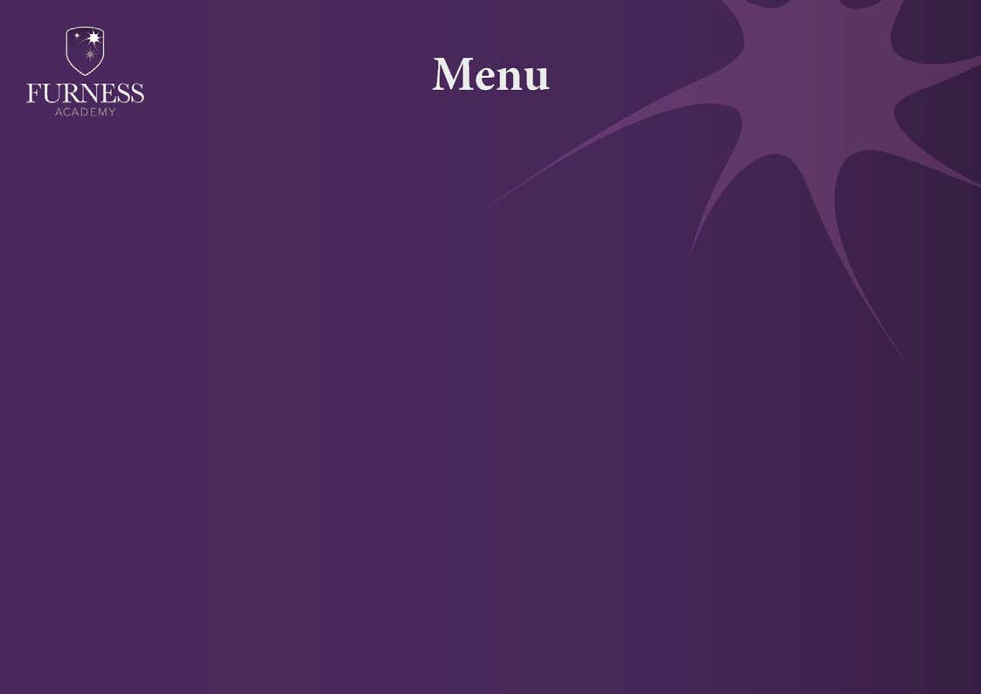  Baked fish and fries
Main Courses | - Hot cheese baguette  - Chinese chicken curry  - Cheese and tomato pizza | - Beans on toast  - Hot cheese baguette | - BBQ burger  - Cheese and tomato pizza | - Fajita chicken flatbread  - Sausage and gravy baguette  - Vegetarian sausage | - Sausage Roll  - Chips and toppings
“One stop spud shop” | Chicken Jalfrezi Bolognaise Coronation Chicken Cajun Chicken  Various cold fillings and beans available daily also includes salad, garlic butter, crispy onions and sauces
Side Dishes | - Garlic Bread  - Beans  - Seasonal veg  - Coleslaw  - Salad | - Beans  - Seasonal veg  - Coleslaw  - Salad  • Peas | - Garlic Bread  - Beans  - Seasonal veg  - Salad  - Coleslaw | - Beans  - Mashed potatoes  - Yorkshire pudding  - Seasonal veg  - Salad  - Coleslaw | - Beans  - Salad  - Coleslaw  - Peas  - Curry sauce and Gravy
Desserts | - Selection of fruit  - Mousse  - Tray bakes  - Cheesecakes | - Selection of fruit  - Mousse  - Tray bakes  - Cheesecakes | - Selection of fruit  - Mousse  - Tray bakes  - Cheesecakes | - Selection of fruit  - Mousse  - Tray bakes  - Cheesecakes | - Selection of fruit  - Mousse  - Tray bakes  - Cheesecakes
A variety of sandwiches and baguettes will be available daily
Assorted Salad boxes and cold pasta pots available on request (24hrs notice required)
Allergens available on request

